### **Linux File Management Commands**

You will spend a great deal of time interacting with the terminal where you will be running commands. Executing commands is the most preferred way of interacting with a Linux system as it gives you total control over the system compared to using the graphical display elements.

For this lesson, and the coming lessons, we will be running commands on the terminal. We are using **Ubuntu OS** and to launch the terminal, use the keyboard shortcut CTRL + ALT + T.

Let’s now delve into the basic file management commands that will help you create and manage your files on your system.

##### **1. pwd Command**

**pwd**, short for the print working directory, is a command that prints out the current working directory in a hierarchical order, beginning with the topmost root directory ( / ).

To check your current working directory, simply invoke the **pwd** command as shown.

$ pwd

The output shows that we are in our home directory, the absolute or full path being **/home/tecmint**.

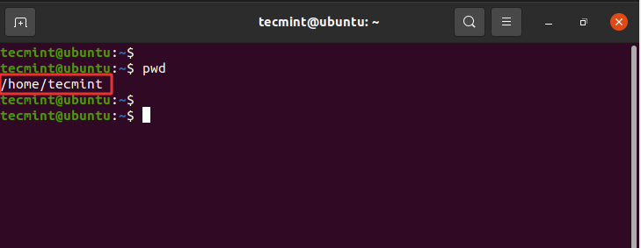Print Current Working Directory

##### 

##### **2. cd Command**

To change or navigate directories, use the [cd command](https://www.tecmint.com/cd-command-in-linux/) which is short for change directory.

For instance, to navigate to the **/var/log** file path, run the command:

$ cd /var/log

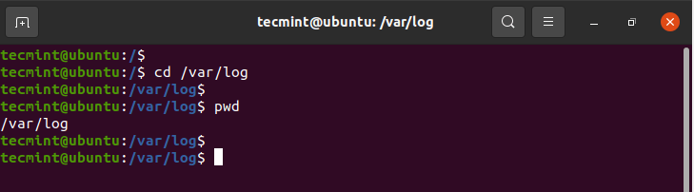Navigate Directories in Linux

To go a directory up append two dots or periods in the end.

$ cd ..

To go back to the home directory run the cd command without any arguments.

$ cd

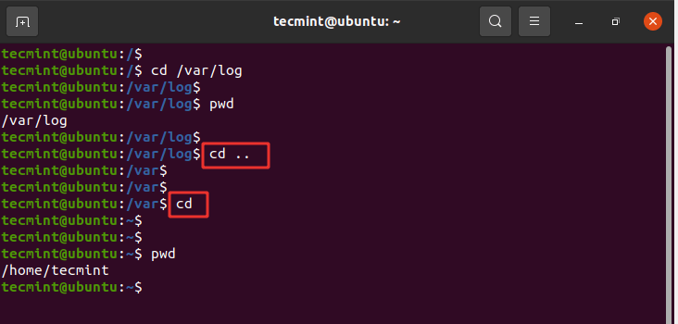cd Command Examples

**NOTE**: To navigate into a subdirectory or a directory within your current directory, don’t use a forward slash ( / ) simply type in the name of the directory.

For example, to navigate into the Downloads directory, run:

$ cd Downloads

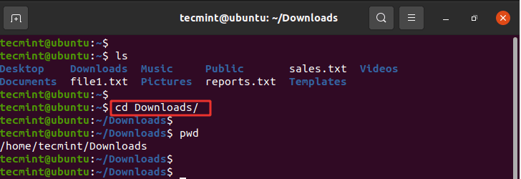Navigate to Downloads Directory

##### 

##### 

##### 

##### 

##### 

##### 

##### 

##### 

##### 

##### **3. ls Command**

The [ls command](https://www.tecmint.com/15-basic-ls-command-examples-in-linux/) is a command used for listing existing files or folders in a directory. For example, to list all the contents in the home directory, we will run the command.

$ ls

From the output, we can see that we have two text files and eight folders which are usually created by default after installing and logging in to the system.

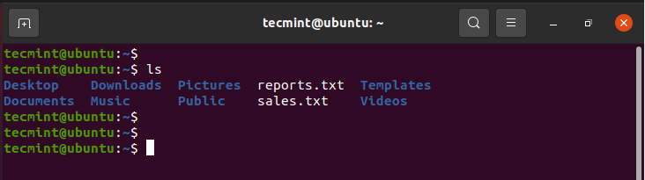List Files in Linux

To list more information append the -lh flag as shown. The -l option stands for long listing and prints out additional information such as file permissions, user, group, file size, and date of creation. The -h flag prints out the file or directory size in a human-readable format.

$ ls -lh

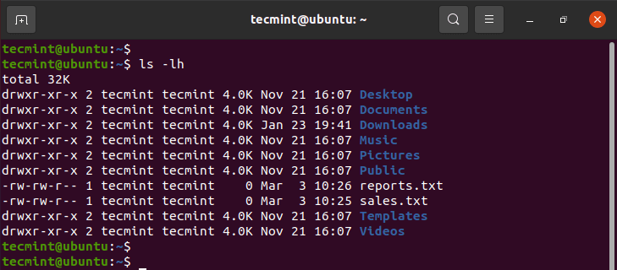Long List Files in Linux

To list hidden files, append the -a flag.

$ ls -la

This displays hidden files which start with a period sign (.) as shown.

.ssh

.config

.local

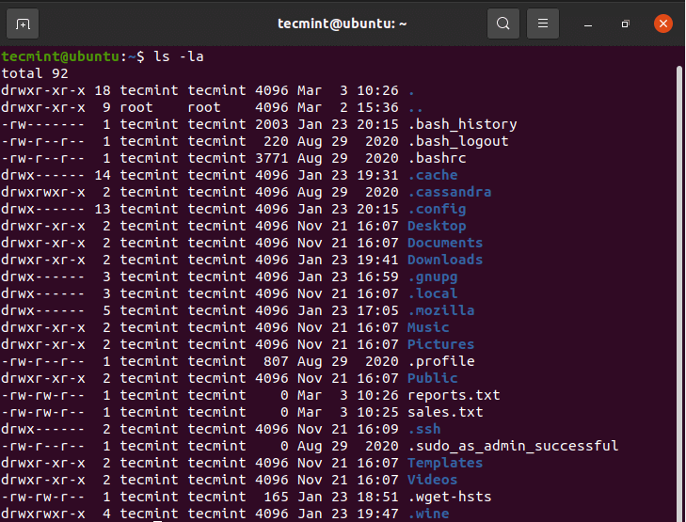List Hidden Files in Linux

##### 

##### 

##### **4. touch Command**

The touch command is used for **creating** simple files on a Linux system. To create a file, use the syntax:

$ touch filename

For example, to create a **file1.txt** file, run the command:

$ touch file1.txt

To confirm the creation of the file, invoke the **ls command**.

$ ls

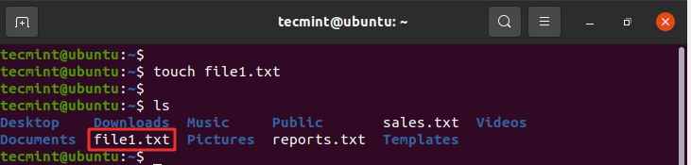Create Empty File in Linux

##### 

##### 

##### 

##### 

##### 

##### **5. cat Command**

To view the contents of a file, use the **cat** command as follows:

$ cat filename

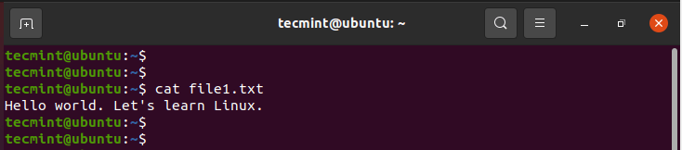View Contents of Files

##### 

##### **6. mv Command**

The **mv command** is quite a versatile command. Depending on how it is used, it can rename a file or move it from one location to another.

To move the file, use the syntax below:

$ mv filename /path/to/destination/

For example, to move a file from the current directory to the Public/docs directory, run the command:

$ mv file1.txt Public/docs

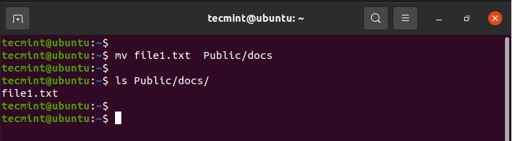Move Files in Linux

Alternatively, you can move a file from a different location to your current directory using the syntax shown. Take note of the period sign at the end of the command. This implies this location’.

$ mv /path/to/file .

We are now going to do the reverse. We will copy the file from the Public/docs path to the current directory as shown.

$ mv Public/docs/file1.txt .

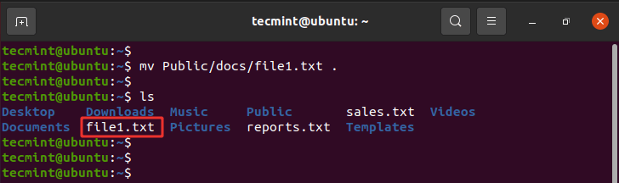Move Files from Location in Linux

To rename a file, use the syntax shown. The command removes the original file name and assigns the second argument as the new file name.

$ mv filename1 filename2

For example, to rename file1.txt to file2.txt run the command:

$ mv file1.txt file2.txt

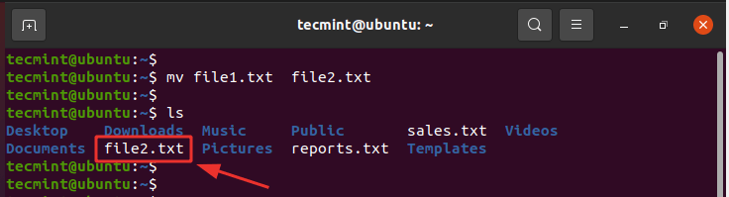Rename Files in Linux

Additionally, you can move and rename the file at the same time by specifying the destination folder and a different file name.

For example to move **file1.txt** to the location **Public/docs** and rename it **file2.txt** run the command:

$ mv file1.txt Public/docs/file2.txt

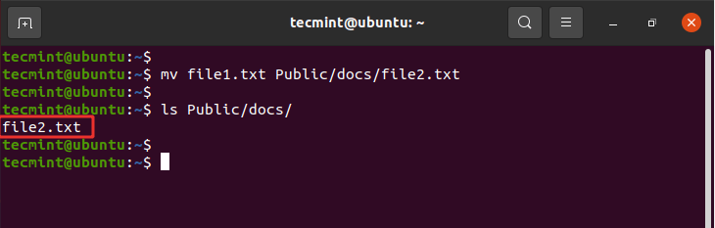

Move and Rename Files in Linux

##### **7. cp Command**

The **cp** command, short for copy, copies a file from one file location to another. Unlike the move command, the **cp** command retains the original file in its current location and makes a duplicate copy in a different directory.

The syntax for copying a file is shown below.

$ cp /file/path /destination/path

For example, to copy the file **file1.txt** from the current directory to the **Public/docs/** directory, issue the command:

$ cp file1.txt Public/docs/

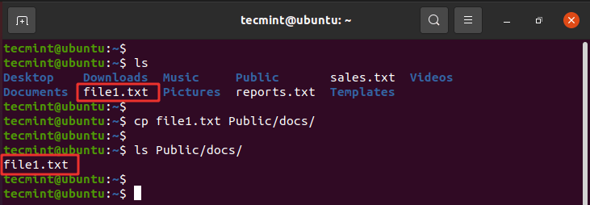Copy Files in Linux

To copy a directory, use the -R option for recursively copying the directory including all its contents. We have created another directory called **tutorials**. To copy this directory alongside its contents to the **Public/docs/** path, run the command:

$ cp -R tutorials Public/docs/

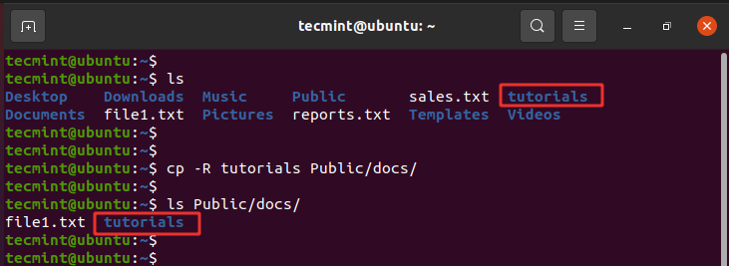Copy Directory in Linux

##### 

##### 

##### 

##### 

##### 

##### 

##### 

##### **8. mkdir Command**

You might have wondered how we created the **tutorials** directory. Well, it’s pretty simple. To create a new directory use the **mkdir** ( **make directory**) command as follows:

$ mkdir directory_name

Let’s create another directory called **projects** as shown:

$ mkdir projects

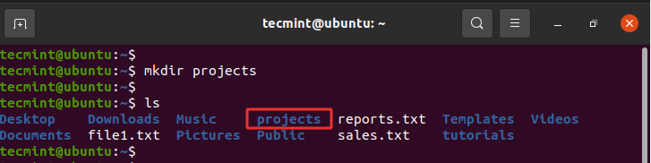Create Directory in Linux

To create a directory within another directory use the -p flag. The command below creates the fundamentals directory inside the **linux** directory within the parent directory which is the **projects** directory.

$ mkdir -p projects/linux/fundamentals

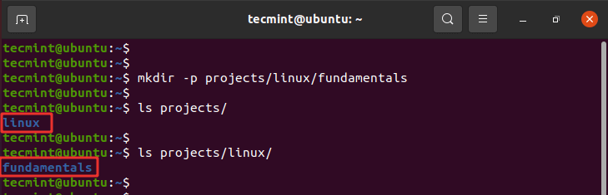

Create Directory in Linux

##### 

##### **9. rmdir Command**

The **rmdir** command deletes an empty directory. For example, to delete or remove the **tutorials** directory, run the command:

$ rmdir tutorials

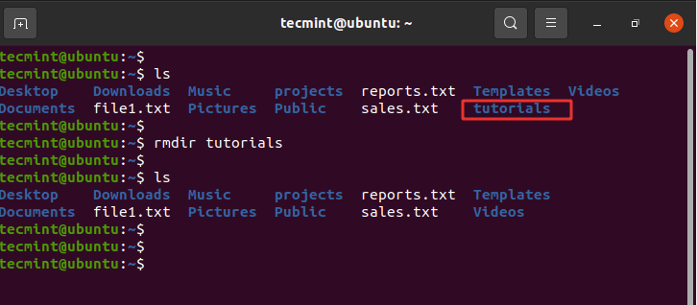Delete Empty Directory in Linux

If you try to remove a non-empty directory, you will get an error message as shown.

$ rmdir projects

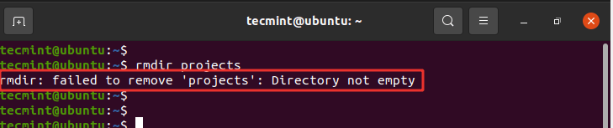Delete Directory in Linux

##### 

##### 

##### **10. rm Command**

The **rm** (remove) command is used to delete a file. The syntax is quite straightforward:

$ rm filename

For example, to delete the **file1.txt** file, run the command:

$ rm file1.txt

Additionally, you can remove or delete a directory recursively using the -R option. This could either be an empty or a non-empty directory.

$ rm -R directory_name

For example, to delete the **projects** directory, run the command:

$ rm -R projects

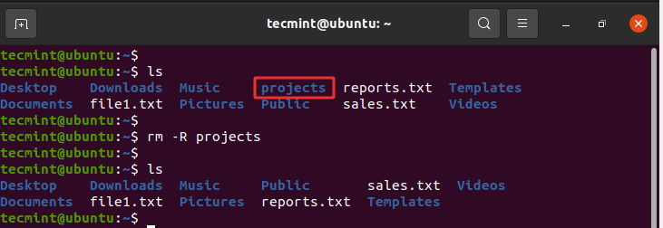Delete Directory Recursively in Linux

##### 

##### 

##### **11. find and locate Commands**

Sometimes, you may want to search the location of a particular file. You can easily do this using either the **find** or **locate** commands.

The **find** command searches for a file in a particular location and takes two arguments: the search path or directory and the file to be searched.

The syntax is as shown

$ find /path/to/search -name filename

For example, to search for a file called **file1.txt** in the home directory, run:

$ find /home/tecmint -name file1.txt

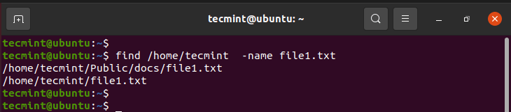Search Files in Linux

The **locate** command, just like the **find** command, plays the same role of searching files but only takes one argument as shown.

$ locate filename

For example;

$ locate file1.txt

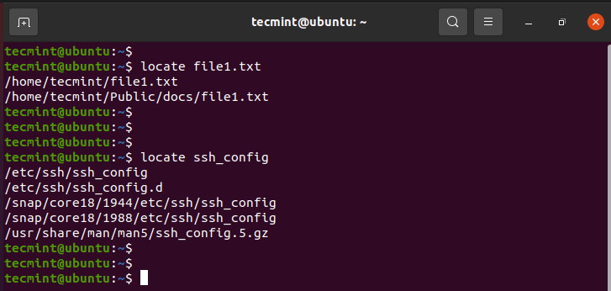Locate Files in Linux

The **locate** command searches using a database of all the possible files and directories in the system.

**NOTE**: The **locate** command is much faster than the **find** command. However, the **find** command is much more powerful and works in situations where **locate** does not produce the desired results.